ML Project Report: Tourism Spending Prediction

Team Members
- Jayant Sharma - IMT2023523
- Akshat Betala - IMT2023019
- Avancha Dedeepya - IMT2023006
Github Link: https://github.com/Akshat089/ML-project-2 (multinomial branch)

Task
Predicting tourist spending behavior is a multi-class classification problem, where the target variable is spend_category (0: Low, 1: Medium, 2: High). Unlike binary classification, this task requires the model to discern between three distinct levels of financial behavior based on travel demographics, package inclusions, and trip duration. The goal is to maximize the weighted F1-score to ensure accurate classification across all spending groups.

Dataset and Features Description
Understanding tourist spending patterns is critical for the travel industry to optimize packages and pricing strategies. This dataset contains information about travelers, their demographics, trip details, and the specific items included in their travel packages (e.g., food, transport).
The dataset is divided into training and testing sets. The objective is to classify the spend_category.

Data Fields
Here is a description of the features found in the dataset:
- trip_id – Unique identifier for each recorded trip.
- country – Country of origin or residence of the traveler.
- age_group – Age group of the primary traveler (e.g., 15-24, 25-44).
- travel_companions – Type of travel company (e.g., Alone, With Family).
- num_females/num_males – Number of female/male travelers in the group.
- main_activity – Primary activity (e.g., Beach, Wildlife).
- visit_purpose – Main purpose of visit (Leisure, Business).
- mainland_stay_nights – Number of nights stayed on the mainland.
- island_stay_nights – Number of nights stayed on islands.
- tour_type – Classification of tour (Package vs. Independent).
- inclusions – Multiple binary columns indicating if items like food, transport, tickets, or insurance were included.
- days_booked_before_trip – Days between booking and travel.
- total_trip_days – Categorized duration of the trip.
- spend_category – (Target Variable) 0 (Low), 1 (Medium), 2 (High).

EDA and Pre-processing
The following section outlines the exploratory analysis and feature engineering strategies used to overcome the "linear ceiling" and improve model performance.

1. Import Libraries and Load Data
We loaded the training and testing datasets. Initial inspection revealed that the target variable spend_category was missing in some training rows, which were dropped to ensure data integrity.

2. Target Variable Analysis
The target is a multi-class variable (0, 1, 2). Class imbalance was observed, necessitating the use of class_weight='balanced' in all models to prevent the model from biasing towards the most frequent spending category.

3. Handling Missing Values
Numerical Imputation: Columns like num_females or mainland_stay_nights were imputed with 0 or the median, under the assumption that NaN often implies "none".
Categorical Imputation: Missing values in categorical columns (e.g., age_group, info_source) were filled with a specific 'Missing' placeholder or the most frequent value.

4. Advanced Feature Engineering
To capture the true drivers of cost, we engineered "Interaction Features":
- Group Size: Sum of num_females and num_males.
- Total Nights: Sum of mainland and island stay nights.
- Person-Nights (Crucial): Calculated as GroupSize\TotalNights. This single feature represents the total volume of the trip and was a massive predictor of cost.
- Log Transformation: Financial and time-based features (total_nights, person_nights) followed a Power Law distribution (right-skewed). We applied np.log1p to normalize them, significantly helping the linear models.

5. Encoding Strategy
Unchaining Ordinals: Instead of mapping age_group to 1, 2, 3, 4, we treated it as a nominal category using One-Hot Encoding. This allowed the model to learn non-linear weights (e.g., middle-aged people spend more than both young and old).
Polynomial Features: We applied PolynomialFeatures(degree=2) to numeric columns. This mathematically forced the linear models to see "curved" relationships (like TotalNights^2).

6. Scaling
We utilized StandardScaler to normalize the feature range, which is mandatory for distance-based algorithms like SVM and regularization-based models like Logistic Regression.

7. EDA
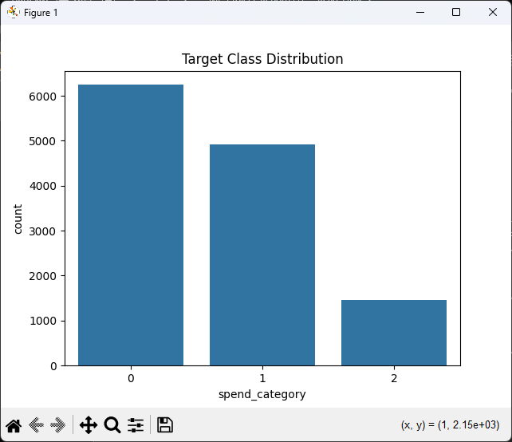

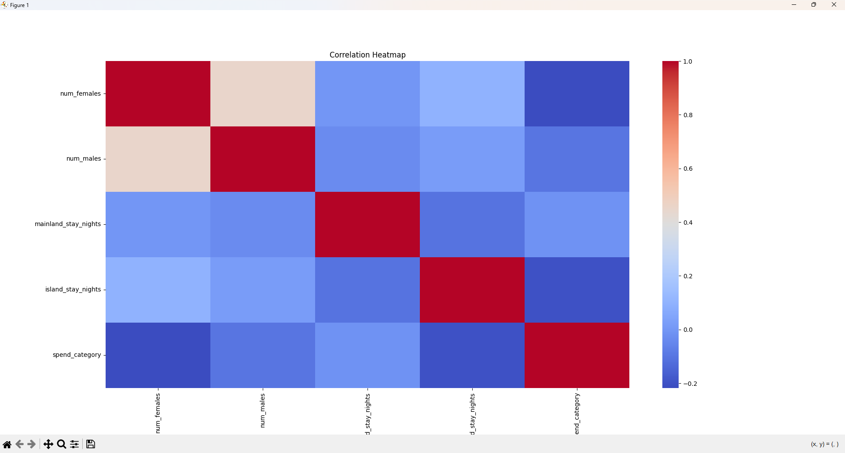

Model Training and Validation
- Metric: We used F1-Weighted score to evaluate performance, ensuring balanced accuracy across all three spending classes.
- Validation: We employed RandomizedSearchCV with 3-Fold Cross-Validation for hyperparameter tuning.

Models Used for Training

1. Voting Ensemble (Logistic Regression Variants)
- Architecture: A soft-voting ensemble of three distinct Logistic Regression models:
  - Standard LR: (solver='lbfgs') capturing general trends.
  - Lasso LR: (penalty='l1', solver='saga') performing feature selection by shrinking noise to zero.
  - Ridge LR: (penalty='l2', solver='saga') handling multicollinearity.
- Preprocessing: Included Polynomial Features (Degree 2) to capture interactions.
- Performance: This was the Champion Model, achieving a score of 0.711.
- Analysis: The combination of polynomial expansion (to see curves) and ensembling (to average out errors) allowed this "linear" approach to outperform complex non-linear models.

2. Support Vector Machine (RBF Kernel)
- Optimization: We used RandomizedSearchCV to tune C (Regularization) and gamma (Kernel coefficient) over a log-uniform distribution.
- Parameters: Best results were found with C ≈ 10-100 and class_weight='balanced'.
- Performance: Achieved a score of 0.695.
- Analysis: While SVMs are powerful, the RBF kernel struggled slightly with the high dimensionality introduced by One-Hot Encoding compared to the robust Voting Ensemble.

3. Artificial Neural Network (ANN)
- Architecture: A standard Multi-Layer Perceptron (MLP).
- Performance: Achieved a score of 0.675.
- Analysis: The ANN performed the worst among the top contenders. This suggests the dataset size was likely too small for a Neural Network to effectively learn the representation without overfitting, compared to the more structured regression approaches.

Interesting Observations

1. The "Polynomial Trick" Breached the Ceiling
Initially, standard Logistic Regression models were stuck at a score of 0.694. By introducing PolynomialFeatures(degree=2), we allowed the linear solvers to model interaction effects (e.g., Large Group AND Long Stay = Exponential Cost). This jumped the score to 0.711, proving that feature engineering is often more powerful than model complexity.

2. Ensembling "Lasso" and "Ridge"
The Voting Ensemble proved that diverse regularization strategies work better together. The Lasso model (L1) effectively removed noisy features (like irrelevant countries), while the Ridge model (L2) kept the signal from correlated features. Averaging them provided a stable, generalized prediction.

3. The Dominance of "Person-Nights"
EDA revealed that total_nights or group_size alone were weak predictors. However, the engineered feature person_nights (People \times Nights) had the highest correlation with spending. This confirms that for tourism data, the "volume" of consumption is the primary driver of the spending category.

4. SVM vs. Ensemble
It was unexpected that the RBF SVM (0.695) lost to the Logistic Ensemble (0.711). Typically, RBF kernels excel at non-linear classification. This failure implies that the decision boundaries between Low, Medium, and High spending are relatively smooth and well-defined by the polynomial interactions, rather than requiring the complex, jagged boundaries that SVMs or Neural Networks generate.

References
https://scikit-learn.org/stable/modules/ensemble.html#voting-classifier
https://scikit-learn.org/stable/modules/generated/sklearn.preprocessing.PolynomialFeatures.html
https://scikit-learn.org/stable/modules/svm.html
https://scikit-learn.org/stable/modules/linear_model.html#logistic-regression

